## Reports Menu/ Pharmacist Report/Daily Visual Verify Check:

Request:

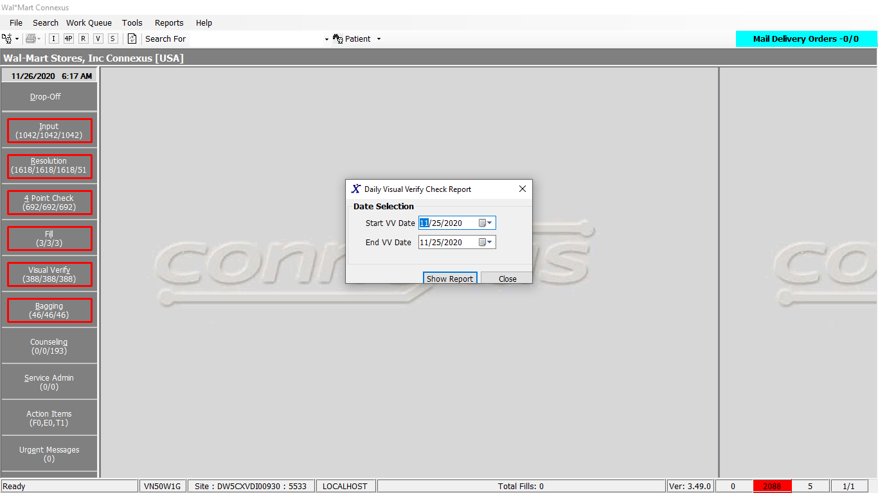

Response:

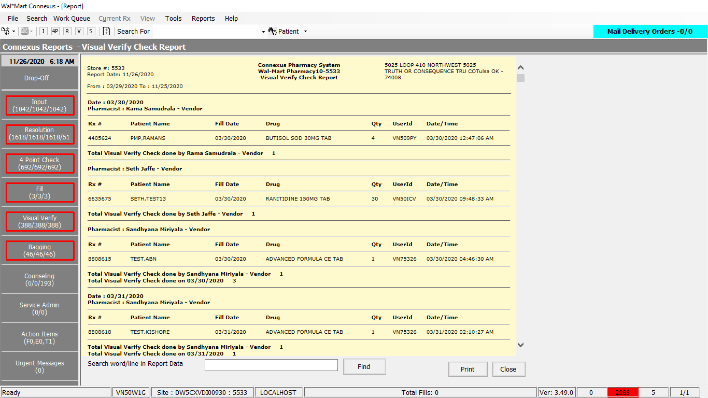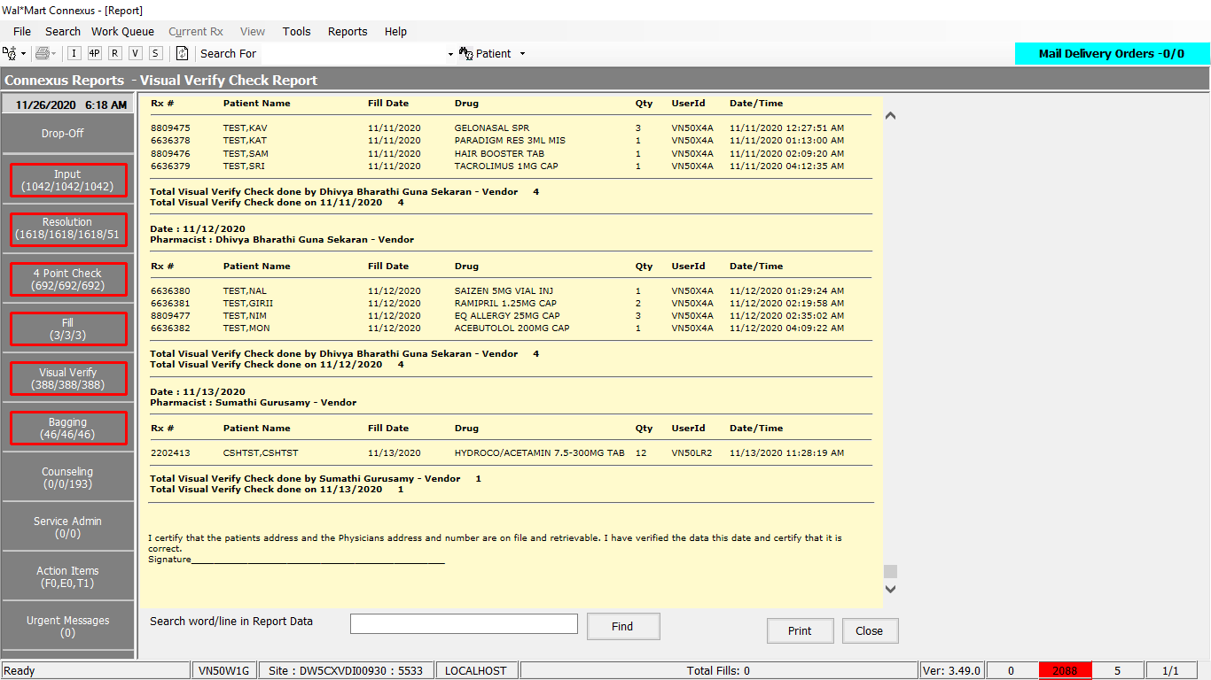

Queries:

Friend Const GetVisChkRptData As String = "SELECT DT2DATE(rxfa.activity_ts) activity_date, rxf.rph_of_rec_userid userid, rx.rx_nbr, rxf.fill_date, CASE when rx.compound_ind != 'Y' then pp.short_name ELSE 'COMPOUND' end drug, rxf.fill_qty, su.user_descr, rxfa.activity_ts, TRIM(NVL(pa.last_name,'')) || ',' || TRIM(NVL(pa.first_name,'')) || ' ' || TRIM(NVL(pa.middle_name,'')) Name, rx.rx_id, rx.rx_version_seq_nbr FROM rx, patient pa, rx_fill rxf, rx_fill_item rfi, OUTER (pharmacy_offering:pharmacy_product pp, pharmacy_offering:pharmacy_item pi), phm_appl_security:system_user su , rx_fill_activity rxfa WHERE DT2DATE(rxfa.activity_ts) >= ? AND DT2DATE(rxfa.activity_ts) <= ? AND rxfa.rx_fill_id = rxf.rx_fill_id AND rxfa.activity_code = ? AND rxfa.activity_seq_nbr = (select MAX(activity_seq_nbr) FROM rx_fill_activity rxfa1 WHERE rxfa1.rx_fill_id= rxfa.rx_fill_id AND rxfa1.rx_fill_id= rxfa.rx_fill_id AND rxfa1.activity_code = ? ) AND pa.patient_id = rx.patient_id AND rxf.rx_id = rx.rx_id AND rxf.rx_version_seq_nbr = rx.rx_version_seq_nbr AND rxf.rph_of_rec_userid IS NOT NULL AND rxf.rx_fill_id = rfi.rx_fill_id AND rfi.item_seq_nbr = 1 AND rfi.item_mds_fam_id = pi.mds_fam_id AND pi.product_mds_fam_id = pp.product_mds_fam_id AND rxf.status_code in ( ? , ? , ? ) AND rx.status_code in ( ? , ? , ? ) AND UPPER(rxf.rph_of_rec_userid)= UPPER(su.userid) AND UPPER(rxfa.activity_userid)= UPPER(su.userid) AND NVL(rxfa.activity_store_nbr, 0) = NVL(su.store_nbr, 0) ORDER BY 1,2,8"

DAL:

Public Function GetVisChkRptData(ByVal siteId As Integer,

ByVal startDate As DateTime, ByVal endDate As DateTime) _

As List(Of GetVisChkRptDataInfoBE) Implements IReportDAL.GetVisChkRptData

Using (New Tracer(ConnexusCommonConstants.ConnexusTracer))

Dim getVisChkRptDataBEList As New List(Of GetVisChkRptDataInfoBE)

Dim paramList As New List(Of DbParameter)

paramList.Add(ParameterHelper.BuildParameter("StartDate", DbType.Date, startDate))

paramList.Add(ParameterHelper.BuildParameter("endDate", DbType.Date, endDate))

paramList.Add(ParameterHelper.BuildParameter("VisulCheck", DbType.Int32, Activity.VisualCheck))

paramList.Add(ParameterHelper.BuildParameter("VisulCheck", DbType.Int32, Activity.VisualCheck))

paramList.Add(ParameterHelper.BuildParameter("FillActive", DbType.Int32, FillStatusCodes.FillActive))

paramList.Add(ParameterHelper.BuildParameter("FillHold", DbType.Int32, FillStatusCodes.FillHold))

paramList.Add(ParameterHelper.BuildParameter("FillXferred", DbType.Int32, FillStatusCodes.FillXferred))

paramList.Add(ParameterHelper.BuildParameter("RxActive", DbType.Int32, RxStatusCodes.RxActive))

paramList.Add(ParameterHelper.BuildParameter("RxHold", DbType.Int32, RxStatusCodes.RxHold))

paramList.Add(ParameterHelper.BuildParameter("RxXfered", DbType.Int32, RxStatusCodes.RxXferred))

Dim dataReader As IDataReader = ExecuteReader(DatabaseEnum.rx21c, siteId, ReportQueries.GetVisChkRptData, paramList)

Dim getVisChkRptDataBE As GetVisChkRptDataInfoBE

While dataReader.Read

getVisChkRptDataBE = New GetVisChkRptDataInfoBE

If Not dataReader.IsDBNull(dataReader.GetOrdinal("activity_date")) Then

getVisChkRptDataBE.ActivityDate = CDate(dataReader("activity_date"))

End If

If Not dataReader.IsDBNull(dataReader.GetOrdinal("activity_ts")) Then

getVisChkRptDataBE.ActivityTs = CDate(dataReader("activity_ts"))

End If

If Not dataReader.IsDBNull(dataReader.GetOrdinal("drug")) Then

getVisChkRptDataBE.Drug = CStr(dataReader("drug")).Trim

End If

If Not dataReader.IsDBNull(dataReader.GetOrdinal("fill_date")) Then

getVisChkRptDataBE.FillDate = CDate(dataReader("fill_date"))

End If

If Not dataReader.IsDBNull(dataReader.GetOrdinal("fill_qty")) Then

getVisChkRptDataBE.FillQty = CInt(dataReader("fill_qty"))

End If

If Not dataReader.IsDBNull(dataReader.GetOrdinal("Name")) Then

getVisChkRptDataBE.Name = CStr(dataReader("Name")).Trim

End If

If Not dataReader.IsDBNull(dataReader.GetOrdinal("rx_id")) Then

getVisChkRptDataBE.RxId = CInt(dataReader("rx_id"))

End If

If Not dataReader.IsDBNull(dataReader.GetOrdinal("rx_nbr")) Then

getVisChkRptDataBE.RxNbr = CInt(dataReader("rx_nbr"))

End If

If Not dataReader.IsDBNull(dataReader.GetOrdinal("rx_version_seq_nbr")) Then

getVisChkRptDataBE.RxVersionSeqNbr = CInt(dataReader("rx_version_seq_nbr"))

End If

If Not dataReader.IsDBNull(dataReader.GetOrdinal("user_descr")) Then

getVisChkRptDataBE.UserDescription = CStr(dataReader("user_descr")).Trim

End If

If Not dataReader.IsDBNull(dataReader.GetOrdinal("userid")) Then

getVisChkRptDataBE.UserId = CStr(dataReader("userid")).Trim

End If

getVisChkRptDataBEList.Add(getVisChkRptDataBE)

End While

If getVisChkRptDataBEList.Count > 0 Then

Return getVisChkRptDataBEList

Else

Return Nothing

End If

End Using

End Function